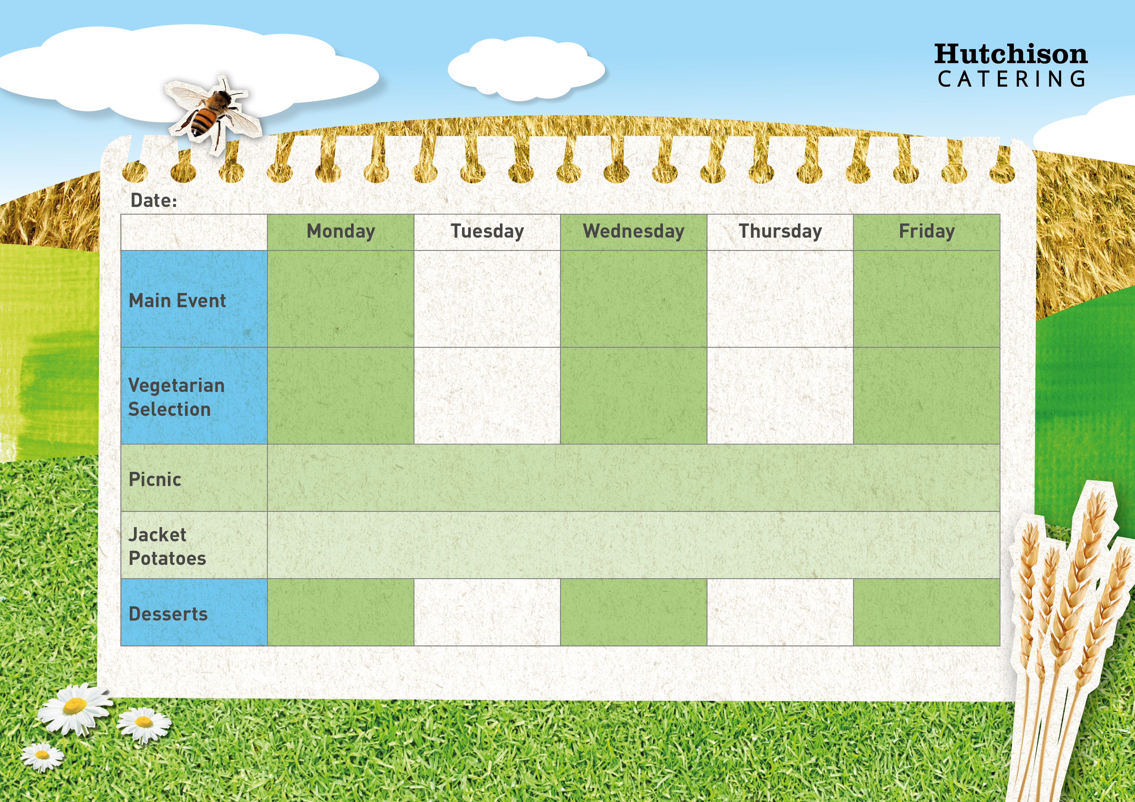

**Autumn Week 1**

Chocolate & Vanilla Swirl

**Crispy Baked Jacket Potato with a Choice of Fillings, Mixed Salad**

**Dessert of the Day or Fresh Fruit**

**Available Daily:** Fresh Bread, Water, Fresh Fruit and Yoghurt

Honey & Oat Muffins

Jelly

Apple Crumble & Custard

Chocolate Crunch Cookie

**Freshly Prepared Sandwich, Wrap or Baguette, with Mixed Salad, Healthy Snack,**

**Dessert of the Day or Fresh Fruit**

Pizza Pinwheels with Chips & Baked Beans or Peas

Vegetable Cottage Pie with Green Beans and Gravy

Veggie Sausage with Creamy Mash Potato, Gravy & Carrots

Tomato and Basil Pasta served with Garlic Bread and Broccoli

Margherita Pizza with Potato Wedges & Sweetcorn

Pepperoni Pizza with Potato Wedges & Sweetcorn

Italian Chicken & Tomato Pasta with Broccoli

Sausages with Creamy Mash Potato, Gravy & Carrots

Cottage Pie with Sweet Potato Top & Green Beans

Crispy Battered Fish with Chips & Baked Beans or Peas