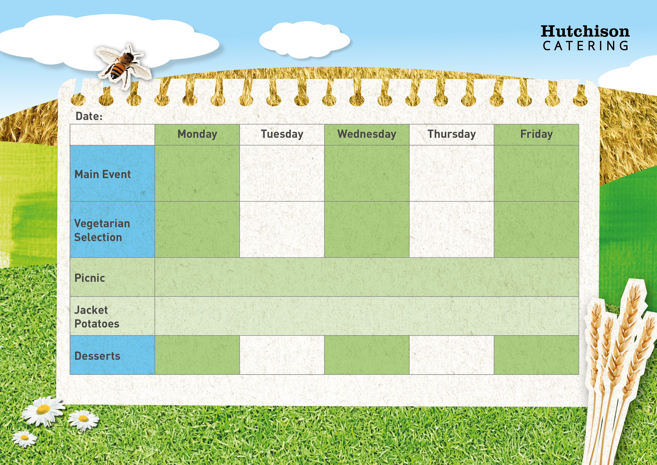

Cheese & Onion Pie with Broccoli

Quorn Meatballs in a Homemade Tomato Sauce with Pasta with Sweetcorn

Meatballs in a Homemade Tomato Sauce with Pasta with Sweetcorn

Chinese Chicken Curry with Rice and Naan Bread

Vanilla Custard Cookies with Fruit

**Available Daily:** Fresh Bread, Water, Fresh Fruit and Yoghurt

Chocolate & Vanilla Marble Cake

Fruit Sponge

Ice Cream Cups

Fruity Flapjack

**Crispy Baked Jacket Potato with a Choice of Fillings, Mixed Salad**

**Dessert of the Day or Fresh Fruit**

**Freshly Prepared Sandwich, Wrap or Baguette, with Mixed Salad, Healthy Snack,**

**Dessert of the Day or Fresh Fruit**

Quorn Burger with Chips & Peas

All Day Breakfast

Vegetarian Sausage, Hash Browns, Beans and Buttered Bread

Margherita Pizza with Potato Wedges & Vegetable Sticks

Oven Baked Fish Fingers with Chips & Baked Beans or Peas

All Day Breakfast

Sausage, Hash Browns, Beans and Buttered Bread

Ham and Pineapple Pizza with Potato Wedges & Vegetable Sticks

**Autumn Week 2**