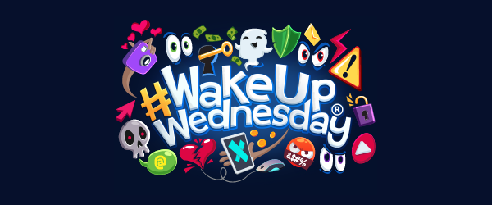

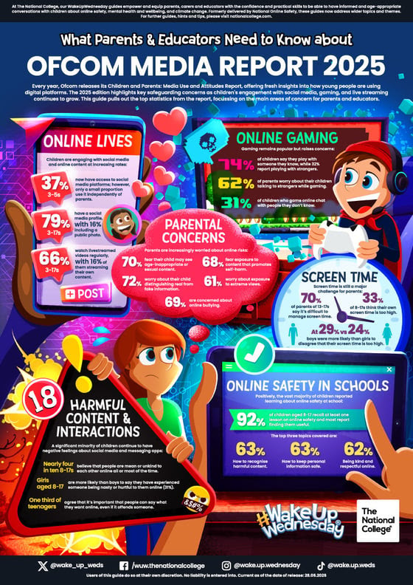

79% of 3–17-year-olds now have a social media profile and many include public photos. Ofcom’s 2025 report reveals young people’s increasing use of online spaces.

The latest Media Use and Attitudes Report from Ofcom is essential reading for educators and parents. Our new #WakeUpWednesday guide pulls out the key findings – from livestreaming and gaming  to screen time  and safety lessons in school.

With children navigating digital spaces from ever-younger ages, staying informed is crucial. This guide provides an update on the latest trends, activities and behaviours of children and young people online, identifying risks so that schools and families better understand where to focus preventive measures and support.

Download your free guide:

https://nationalcollege.com/guides/ofcom-media-report-2025?utm_campaign=WakeUpWednesday&utm_medium=email&_hsenc=p2ANqtz-8_d9ymxrE1la-3vnedvsjWcV79deO5Y57PwbHksV_Z-jlFidbr6MsG9citKtS1bNRrQrt5ltf4R3qe83ElPCDAO1-VRHKxPMlWmzN4GWz7abjs_Yj96eFU7g8lOUAO5OxLDOcL&_hsmi=110335208&utm_content=110335208&utm_source=hs_email